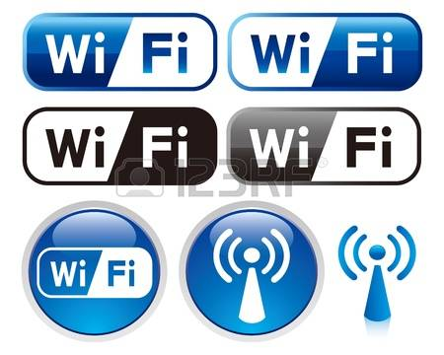
^{How to connect to WiFi}
Look just above your keyboard to the left of the Dell logo. You should see a light up WiFi icon, it is a little oval. It looks like the first one in the image to the right. If you don’t see it, press fn-F2 at the same time. If the icon is showing, your computer has activated its WiFi device.

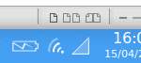
Next look at the lower right hand part of the screen and look for an icon that looks like one quarter of concentric circles which is typical of a WiFi indicator.
This icon is located in the lower right hand of the screen between the battery indicator and the triangle as shown in the image to the right. Since you are not connected, the icon will have a red dot on it. If you are already connected to the Internet with a cable, you may see two arrows instead, one going up and one going down. Whether you have the arrows or another icon in that location, left click it. You should see a menu with your Internet options. Under WiFi networks you should see those that are available to you.
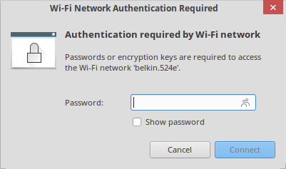
Click on the one you want to connect and enter the WiFi password in the window that shows up that looks like the one to the right. Enter password, click connect and you should be able to access the Internet.

